Executive Summary 2
Business Rules Engine 2
The Key Components 2
Supercharging Digital Processes 3
Solutions for Every Industry, Every User 4
A Simplified Rule Deployment 6
Explaining the Results of Business Rules 8
The Plight of Zercovana 8
Key Players 8
Build Decisions with Lookup Tables 8
Decision Matrices at a Glance 9
Decision Tables at a Glance 11
Lookup Tables in Action 12
Prepare the Table 13
Create a Standard Decision Matrix 13
Orchestrate Rules with Expression Sets 15
Expression Sets at a Glance 15
Expression Sets in Action 17
Create Variables and Constants 19
Call the Decision Matrix 19
Add a Calculation Step 20
Add Up All the Fees 21
Save the Rule and Simulate 22
Expression Set Templates 24
Implement Rules in Business Processes 25
Business Rules Deployment 25
Tying the Knots 26
Reaping the Benefits 28

Executive Summary
Salesforce Business Rules Engine enables organisations to automate complex decisions through a visual, no-code approach. This document explains how business users can build, maintain and integrate reusable rules into digital processes, reducing manual intervention and simplifying logic that would otherwise require complex workflows. Its principal benefits include greater agility, advanced calculation capabilities, flexible integration and clearer explanations of automated outcomes.
The engine combines three complementary tools. Decision matrices map inputs to the outputs of a matching row, making them suitable for straightforward lookups such as prices or base fees. Decision tables support more complex conditions and multiple matching outcomes, including rules based on Salesforce records. Expression sets orchestrate these lookups with calculations, conditions, branching and aggregation to produce results that workflows can consume. Versioning, reuse and simulation support ongoing rule maintenance and testing, while Decision Explainer provides insight into the rationale behind results.
Implementation follows a practical sequence: prepare and activate lookup data, build and simulate an expression set, then integrate the rules into a guided experience. Salesforce Flow and Omnistudio provide workflow integration, while Connect APIs support custom or third-party processes. The workflow collects the required inputs, invokes the rules and presents the returned outputs to the user. The document illustrates applications across financial services, healthcare, insurance, communications, public services and manufacturing.
The fictional Zercovana case study demonstrates this approach through a business licence application pilot. A decision matrix supplies the base application fee, an expression set calculates additional charges and the total fee, and an Omniscript delivers the guided interaction through a business portal. The example shows how separating rule logic from the user experience can simplify implementation and maintenance while giving applicants a clear fee breakdown. Overall, the document presents Business Rules Engine as a flexible foundation for more efficient, maintainable and transparent digital services.

Business Rules Engine

The Key Components
Business Rules Engine is a suite of services, components, and objects that apply advanced logic and automate complex decision-making.
The engine contains three core tools: expression sets, decision matrices, and decision tables.
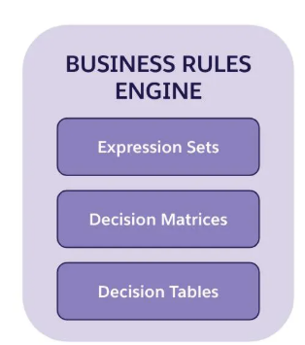
Each tool offers different core functions, and they work together productively and seamlessly.
The table defines each tool.
Tool | Description
Expression set | An expression set is a series of rules you create with expression set elements. Each element in a set forms a logical step that runs sequentially.  Expression sets evaluate conditions, perform mathematical operations, look up decision tables and matrices, and perform multiple transformations simultaneously.  You can add expression sets to workflows created with Flow, Omnistudio, and third-party tools.
Decision matrix | A decision matrix matches input values to a table row and returns the output values of the row.  You can call decision matrices directly inside expression sets or use decision matrices as a standalone tool.
Decision table | A decision table provides multiple matching outcomes for the same set of inputs.  Decision tables read rules from Salesforce objects and support different operators for each field in the object.

You can access each tool from the dedicated Salesforce app called Business Rules Engine.
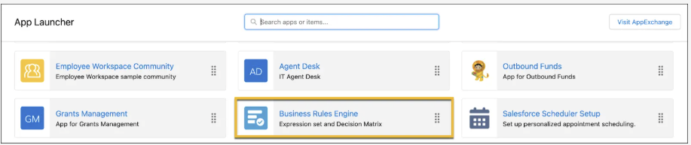

Supercharging Digital Processes
Business Rules Engine enables business users to design automated decisions using a visual designer, intuitively and without code.
The engine powers guided interactions and workflows for just about any industry process. And it operates at a true business-to-consumer scale, capable of maintaining thousands of rules and automating millions of interactions.
Business Rules Engine addresses several issues that teams commonly face across industries.
Challenge | Description
High technical complexity | Complex technical requirements for business-rule implementation mean high costs to companies and slow solution development.
Limited flexibility | Without tools for maintaining and extending decisions, companies get stuck with initial solutions and struggle to iterate and innovate.
Lack of advanced functionality | Without features for handling conditions, aggregation, and lookup tables, solutions are too simplistic to meet the advanced needs of businesses.
Limited integration | Insufficient options for integrating rules with existing business processes mean businesses struggle to implement rules.
Lack of transparency | Customers rarely receive insight into rule processing, often leaving them in the dark and confused about why they can’t complete actions, such as application submission or product selection.
Performance issues | The high volume of business-to-consumer cases often causes severe performance and reliability issues.

At its core, Business Rules Engine solves these common issues. It gives you the agility to reduce manual interventions for a variety of digital processes. Here are some main benefits of Business Rules Engine.
Benefit | Description
Intuitive | Design automated processes using a no-code builder, saving time and money.  Business experts can manage rules by themselves with no need for a team of developers.
Agile | Maintain and extend decisions.  Versioning, modularity, reusability, and other features make it easy to innovate and improve processes continuously.
Functional | Use rich and complex calculation capabilities, including conditions, lookup tables, sub-rules, and aggregation.
Flexible | Embed rules directly in any digital interaction or process with only a few clicks.
Transparent | Explain decisions to users, keeping them informed and engaged about the guided process.
Performant | Maintain thousands of rules and automate millions of interactions, meeting the high-volume needs of business-to-consumer cases.

Solutions for Every Industry, Every User
Business Rules Engine provides solutions for every industry.
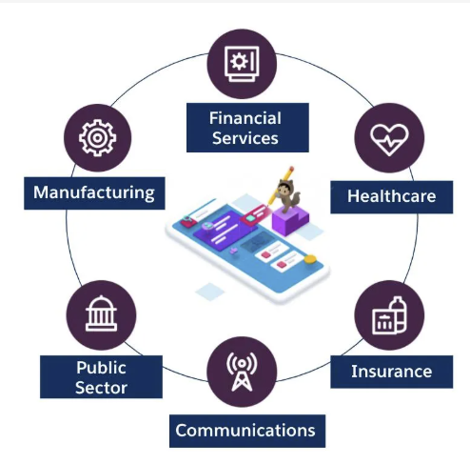
Here are just some ways that Business Rules Engine brings value to different industries.
Industry | Use Cases
Financial Services | - Fee reversal eligibility  - Account alerts triggering conditions
Healthcare | - Prior approval from payer  - Compliance
Insurance | - Quoting and premium calculations  - Claim evaluation
Communications | - Service plan upgrades  - Discount eligibility  - Recommended offering  - CPQ integration
Public Sector | - License and permit applications  - Benefits determinations
Manufacturing | - Partner warranty support  - Internet of Things (IoT) actions  - Asset lifecycle

In addition to providing targeted solutions for different industries, Business Rules Engine serves the distinct needs of different users in every organization.
This table shows how Business Rules Engine facilitates different user jobs and tasks.
User | Jobs to Be Done
Customers | - Apply for eligible services and benefits on their own.  - Understand the reason behind automated decisions.
Business analysts | - Adapt to business changes faster.  - Design business rules on their own.  - Plan for the future with versioned rules.
Customer service representatives | - Evaluate customer circumstances.  - Determine eligibility based on business rules.  - Explain the reasons for rule evaluation to customers.
Salesforce developers | - Easily integrate with existing business processes.  - Ship pre-built rules to customers.

A Simplified Rule Deployment
How to deploy it in an actual business process.
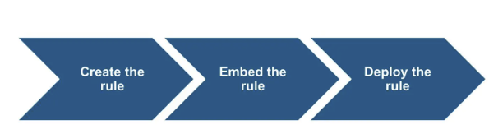
First, you compose your rules using the Expression Set Builder.
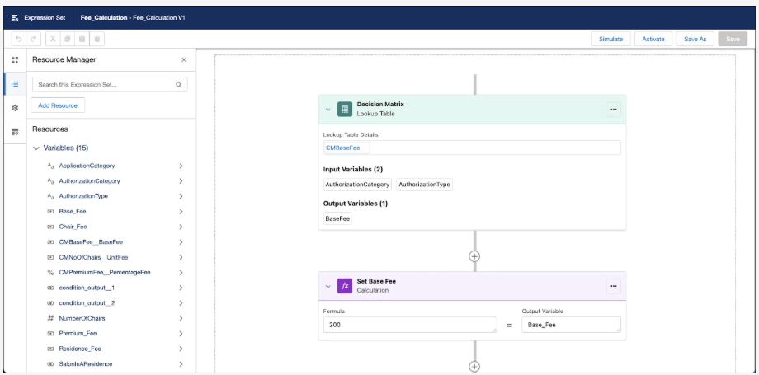
Remember, you can directly add active decision matrices or tables to any expression set.
Next, you embed the rules in a guided experience of your choice using Omniscript or Flow.
Here, you can see how a Salesforce Flow calls an expression set to calculate the discount for a loan.
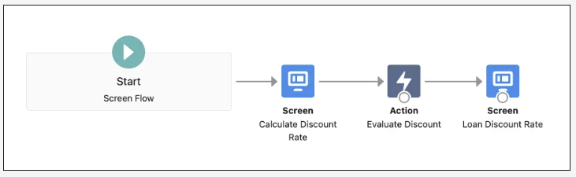
Finally, you deploy the guided experience, and voila! End users enjoy automated decisions in digital interactions.
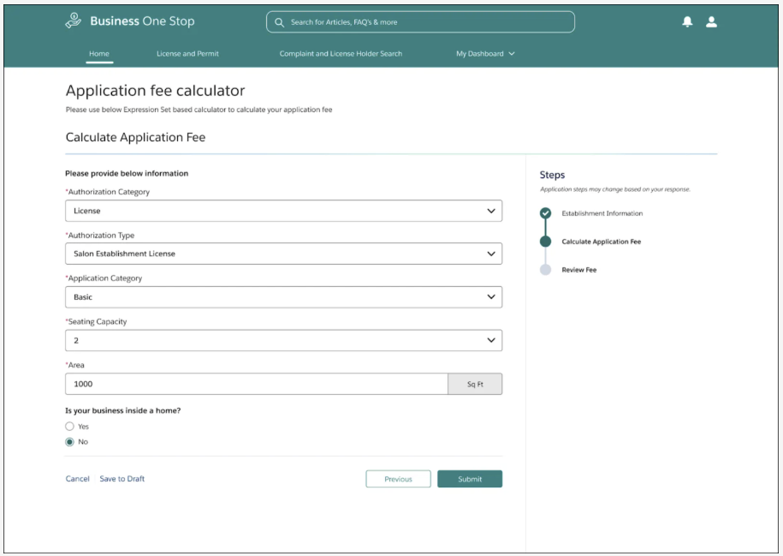

Explaining the Results of Business Rules
Great user experience is built on the pillars of transparency and ease of use. Decision Explainer is a service that provides insight into why a business rule generates a specific result.
You build rules with Business Rules Engine and use Decision Explainer to describe the rationale behind the results. This way, you can rest assured that your users easily understand why a rule executes, so it’s not a puzzle.

The Plight of Zercovana
In the rest of this module, you explore Business Rules Engine through a scenario involving the fictional micronation of Zercovana.
Problem Statement: Zercovana currently faces intense public criticism for its poor provisioning of social services. The nation hasn’t adequately invested in digital solutions, causing cumbersome and unpleasant experiences for its citizens. Zercovanians regularly express discontent with the red tape that seems to entangle every interaction with public services.
To address this public dissent, Zercovana launches the Ease of Doing Business Initiative. As a central pillar in this effort, Zercovana implements Salesforce Government Cloud to streamline and supercharge its license, permit, and inspection-management processes. Zercovana wants to simplify its business license application process using Business Rules Engine for the pilot project.
This application process contains a guided interaction for the applicant to determine the appropriate license application fee. Business Rules Engine automatically calculates the application fee for the interaction.

Key Players
- Jessica Morales, the program manager, is responsible for composing the lookup table and expression set that determines the license application fee.
- Alex Park, a member of Zercovana’s technical staff, builds the guided flow for the application. This process invokes Jessica’s expression set to determine the application fee.
- Donisha Smith, a citizen of Zercovana and a small business owner, then uses the guided flow to determine the license application fee for her business.

Build Decisions with Lookup Tables
Recall that Business Rules Engine includes three core tools: expression sets, decision matrices, and decision tables.
Decision tables and decision matrices are both types of lookup tables.
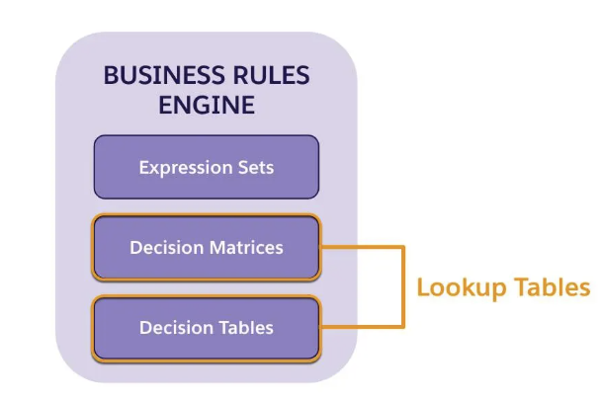
Both tools map input values to output values, but their functionality and use cases differ.
In this unit, let’s learn more about the main features of decision matrices and decision tables.

Decision Matrices at a Glance
Decision matrices are powerful lookup tables that contain user-defined input and output columns. The system takes in inputs and then “looks up” the appropriate outputs. When an expression set or other tool calls a decision matrix, the engine locates the table row that matches the input values and returns the output value for that row.
Here’s an example of a simple decision matrix with one input column–SLA–and two output columns, Retention Cost and Retention Rate.
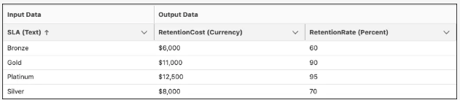
This matrix outputs the retention cost and rate of retention based on service level agreement (SLA) input.
- If the SLA is Gold, the retention cost is $11,000, and the retention rate is 90%.
- If the SLA is Platinum, the retention cost is $12,500, and the retention rate is 95%.
Business users can easily add a matrix to an expression set, or another process as a single element in a more complex calculation.
Decision matrices are helpful whenever a business process needs to determine a particular value based on one or more inputs.
Here are just a few use cases for decision matrices.
- An insurance premium matrix matches the characteristics of the insured person to policy premiums.
- A weather alert matrix sets an alert flag when weather conditions rise or fall below a designated temperature.
- A demographic matrix outputs demographic data based on a location.
- A pricing matrix matches a set of product characteristics to a price.
- An eligibility matrix evaluates a candidate’s eligibility based on their characteristics.
Decision matrices are one of two broad types.
- Standard decision matrices have common characteristics, including input columns, output columns, and versions.
- Grouped decision matrices allow you to group matrix rows by keys such as geographic region or product code.
Decision matrices are flexible in how you can deploy them. You can use them inside of expression sets as part of a larger rule, or you can use them directly in a business process.
With decision matrices, businesses can plan for the future without disrupting current operations. Business users can create multiple versions of a single matrix and then specify their active dates and priority to plan changes well in advance.
Decision matrices are fairly easy to set up, with no code required. After quickly getting up to speed, any business user can create, modify, and maintain decision matrices. Oh, and decision matrices are versatile because business users can do these tasks.
- Create a version of a decision matrix from an existing version, and copy over all the matrix data from the previous version. Nifty, right? To learn more, see Create a Decision Matrix Version from an Existing Version.
- Upload data to a decision matrix using a .csv file, and control the uploaded data. To learn more, see Create or Modify Decision Matrices by Using CSV Files.

Decision Tables at a Glance
Like decision matrices, decision tables are lookup tables that read business rules with multiple inputs and return multiple outputs. A single lookup on a decision table can match multiple rows and return multiple output sets.
Create decision tables in Business Rules Engine, and use them in workflows or expression sets. If you use custom or third-party tools to create workflows, use Connect APIs to integrate decision tables with your workflows.
Decision tables read business rules and return the outcome from Salesforce records or values that you specify. You can also set advanced conditions so that the decision table evaluates records or inputs against the specified logic.
Here’s an example of a decision table with two input columns and one output column.
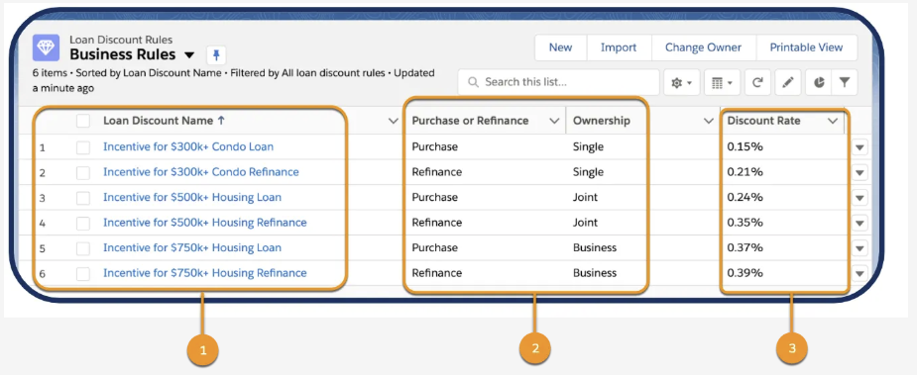
Purchase or Refinance and Ownership are the input columns, and Discount Rate is the output column. Notice the table shows multiple Salesforce records in the first column (1). Unlike decision matrices, where you edit data directly in the table, all of the table data here comes directly from the object records. In turn, table data updates when the record data changes. Based on input characteristics stored in the second and third columns (2), the decision table looks up and outputs the Discount Rate in the final column (3).
In this table, a purchase loan for single ownership yields a 0.15% discount, while a refinancing loan for business ownership yields a 0.39% discount.
After composing this table, a business user adds it to a broader business rule to automatically calculate the terms of a loan. Decision tables can reduce the number of conditional steps to create flows that are easy to orchestrate and maintain.
Let’s look at two flow examples that calculate the loan discount rate.
Here, the flow uses a series of complex conditional elements to calculate the premium, resulting in a messy and overly complex flow. And who wants that?
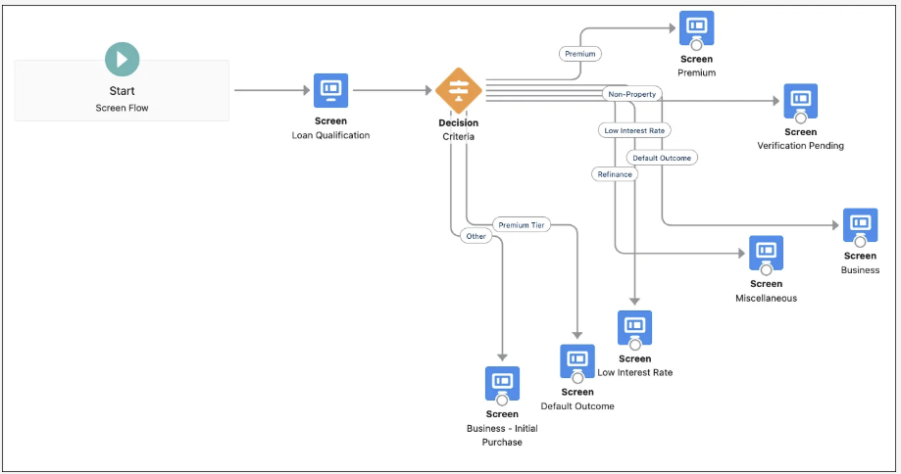
In contrast, the next flow calls on the decision table action to handle all the discount evaluations in one compact step, meaning a much cleaner, streamlined flow. Nice, isn’t it?
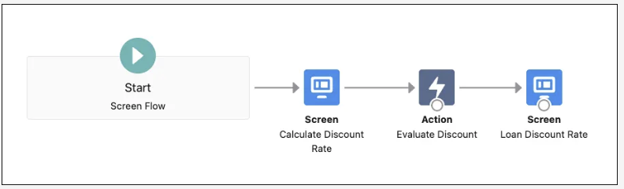
With decision tables, you can orchestrate complex rule evaluations of Salesforce records in a few, simple steps.

Lookup Tables in Action
The nation of Zercovana, which wants to automate and simplify its business license application process with Business Rules Engine.
As a first step, Zercovana must create a lookup table that determines the base fee amount for a license application based on some simple inputs. Then, they add this table to a new expression set that calculates the final fee. Finally, they add the expression set to a user-friendly guided interaction that citizens can use to determine the appropriate fee.
Zercovana’s table for determining the base fee amount is straightforward, with no need to call on complex operators or Salesforce objects. They also already have an existing spreadsheet that contains all the data, which is ideal for importing. For these reasons, Zercovana decides to create a decision matrix rather than a decision table.
Jessica Morales, program manager, creates the decision matrix and expression set.
The process has three main tasks.
- Prepare the table.
- Import the matrix.
- Activate the matrix.

Prepare the Table
You have two ways to add data into a decision matrix: Enter the data manually into Salesforce or import it from a .csv file. It’s typically more efficient to format a rating table from a spreadsheet, save it as a .csv file, and then import the table into the Decision Matrix Designer.
Here’s a pretty basic table with three columns. We’ll name this decision matrix as Base Application Fee.
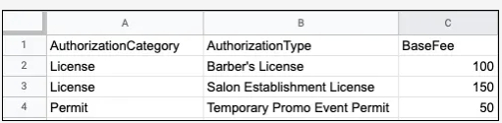

Create a Standard Decision Matrix
After saving the table as a .csv file, open the Decision Matrix Designer and create a new standard matrix.
- Click, then find and select Business Rules Engine.
- Click the app navigation menu, and then select Lookup Tables.
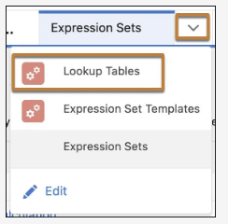
- Click New.
- Select Decision Matrix, and then click Next.
- Enter these details.
  - Name: Base Application FeeCopy
  - Type: Standard
- Click Save.
On the Matrix tab of the new version, click Upload CSV File.

The import process is straightforward. Choose a .csv file, and specify the appropriate header and data types for each column in the matrix.
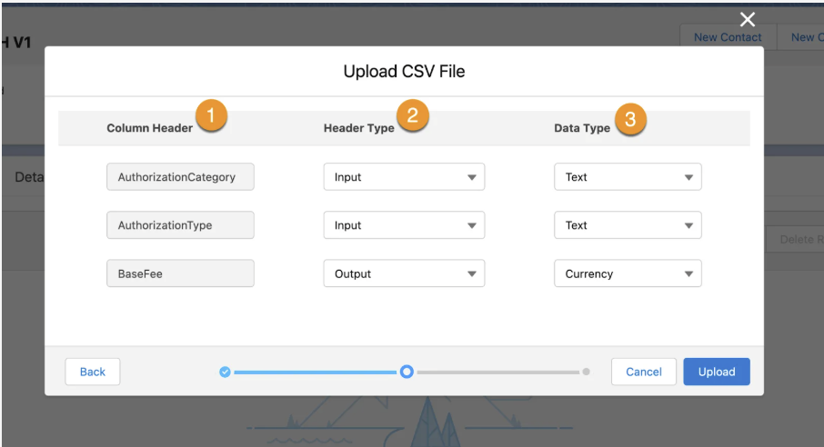
In this table:
- The Column Header (1) fields display the three values from the first row of the spreadsheet. These values function as the headers for the data in each column.
- For Header Type (2), the authorization category and authorization type headers are input columns and the base fee is an output column.
- For Data Type (3), the authorization category and authorization type are Text and the base fee is Currency.
While this table is very simple, Business Rules Engine supports much larger tables, including those with lots of data!
After specifying these fields, upload the matrix. The uploaded data now appears as a cleanly formatted table with the headers, header types, and data types designated. Save the matrix.
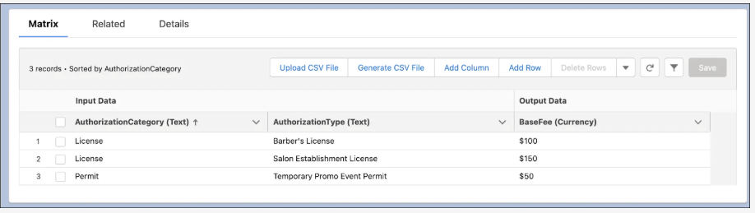
You can now manually add columns or rows to the table. After the matrix is active, you can no longer edit it.
Jessica gives her matrix a final check and likes what she sees. It's ready for activation.
Activate the Matrix
Finally, it’s time to activate the matrix. To do this, open the Base Application Fee V1 decision matrix version, set the active dates and priorities, and click Activate. In the future, you can create a version, make any needed changes to the import or export data, and then specify new active dates and priorities.
Whenever a user calls this expression set, the system automatically selects the correct matrix version based on the dates and priority.
The flexible versioning means Zercovana can plan for the long term in a way that never interferes with existing processes.
Jessica is quite impressed with the ease of setting up the decision matrix. Now that her lookup table is ready, she’s eager to orchestrate the full expression set for determining the license fee. Let’s see how she does it in the next unit.

Orchestrate Rules with Expression Sets

Expression Sets at a Glance
Expression sets are the calculation engine of business rules. They’re made up of variables, constants, and logic connected in a meaningful flow. Expression sets take inputs as formatted JSON data and use lookup tables, algebraic operations, and aggregation operations to calculate new data. Then they output specified data in formatted JSON that guided processes like Omniscripts and Flow can use.
Here are some things you can do with expression sets.
- Integrate them seamlessly with decision tables and decision matrices.
- Build a rule once and reuse it any number of times with different input values.
- Create multiple versions of a single rule to anticipate calculation changes over time.
- Use advanced calculation features such as array calculations, branching, and aggregation functions.
- Simulate expression sets to check that they work, and then modify them as required.
Expression sets can help guide a customer or agent through a series of questions and pull data from various sources. You can use expression sets to deliver quotes or determine eligibility for many use cases, for example:
- A health insurance plan
- A term-life quote
- A volume discount on an order
- A permit or application fee
- A benefits or service determination
When an expression set has multiple factors, values, and calculations, it can call multiple decision matrices.
You build expression sets using, you guessed it, the Expression Set Builder. Use it to easily create expression sets by defining elements and combining them into a sequence.
There are many elements available for use in expression sets. This table briefly defines each type.
Element type | What does it do?
Aggregate | Performs addition, average, maximum, or minimum functions on multiple runs of the preceding steps of the expression set.
Aggregate Group | Runs the previous expression set steps once for each set of input values and then runs the Aggregate steps.
Branch | Shows multiple conditional paths that an expression set can take based on the priority you assign to each path. A branch can have up to six conditional paths, including the default path. All non-default paths require a condition step, which evaluates the entry criteria for the path.
Business Elements | Solution-specific, customized elements that are designed specifically for your industry’s business requirements. Business elements are shipped as part of your Industries solution. When a business element is available in your org, you can add the element to an expression set and use the element like other step elements.
Calculation | Performs one or more functions or mathematical operations on variables, constants, and numbers and returns a single result.
Condition | Allows the steps that follow it to run if its expression evaluates to true.
Conditional Group | Runs a group of steps if its Condition step expression evaluates to true.
Lookup Table | Looks for and matches input values to rows in a decision matrix or a decision table, and returns the output of that row.
Sub Expression | Runs a child expression set and returns its results to the parent.

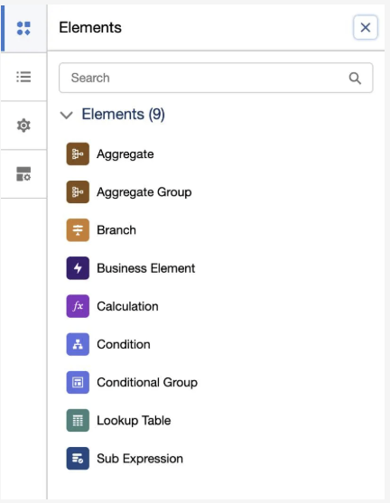
In addition to these core elements, expression sets contain additional handy features, like access control, versioning, and a live simulation tool.
And you can easily save, copy, and reuse expression sets, saving time and effort for similar processes.

Expression Sets in Action
Jessica Morales configured and enabled a decision matrix that determines the base fee for the business application license fee.
Now, it’s time for her to create an expression set that invokes this matrix. This expression set also calls calculation and conditional elements to determine the final fee. Let’s see how she does it.
- Click , and then find and select Expression Sets.
- Click New.
- For Name, enter Application Total FeeCopy.
- For Usage Type, select Default from the dropdown.
- Click Save.
After creating and naming the expression set, click the Application Total Fee V1 expression set version to open it in the expression set builder.
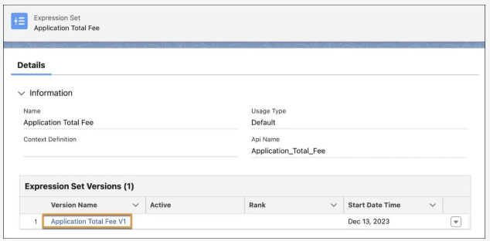
The Expression Set Builder has two main areas.
- Canvas (1) - The canvas is where you create rules by adding various elements.
- Configuration Panel (2) - The configuration panel is where you’ll find additional resources and settings to configure your expression set.
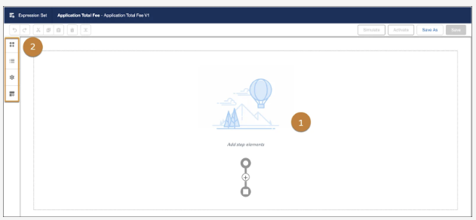
The Configuration Panel consists of the following options.
- Elements : Use this option to view a list of all the available elements.
- Resource Manager : Use this option to create variables and constants.
- Expression Set Properties : Use this option to add additional details such as Start and End date and time, Version Number, and Rank. You can also choose to show decision explanations for the steps in an expression set version if required.
- Element Details : Use this option to include an element in the output.

Create Variables and Constants
Jessica’s first order of business is to add the variables and constants because her calculation steps need to reference them. A variable is a placeholder for a dynamic value. A constant is a placeholder for a fixed value.
To do this, click Add Resource, which opens a dialog for defining variables and constants. The Add New Resource window contains some simple fields, such as Resource Type, Variable API Name, and Data Type, which you fill out with the appropriate values.
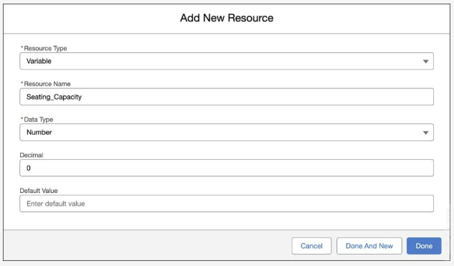
Notice the Resource Type field is set to Variable. The Seating_Capacity resource needs to be a variable because the user defines its value during the guided process.
In this scenario, Jessica creates the following resources.
Resource Type | Resource Name | Data Type | Decimal | Default Value
Variable | Seating_Capacity | Number | 0
Constant | Seating_Capacity_Base_Fee | Currency | 2 | 20
Variable | Additional_Fee | Currency | 2
Variable | Total_Fee | Currency | 2

Call the Decision Matrix
After adding all the required constants and variables, add the first element, which invokes the decision matrix created previously.
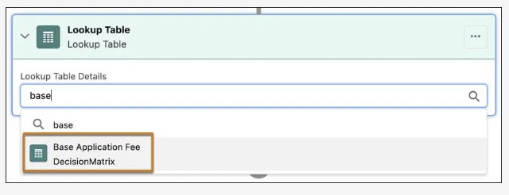
Find and select the matrix called Base Application Fee. A summary of input and output columns for the matrix appears.
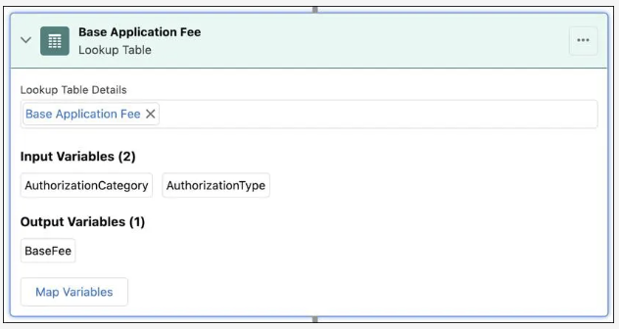
Review the input and output variables and confirm you selected the correct matrix.

Add a Calculation Step
Next, Jessica adds a calculation step that computes an additional fee based on the seating capacity of the business.
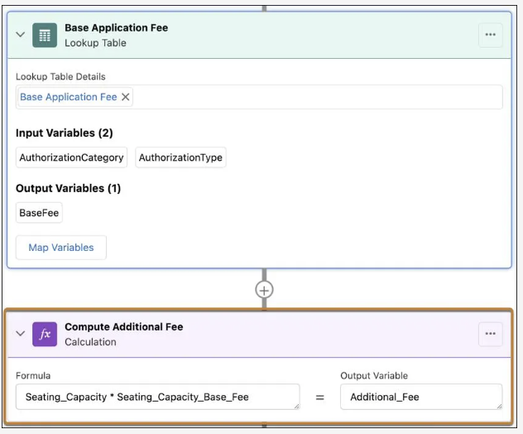
Additional_Fee is calculated by multiplying the Seating_Capacity variable by the Seating_Capacity_Base_Fee constant. Type-ahead functionality makes it easy to reference the appropriate variables and constants in an expression.

Add Up All the Fees
After adding the additional fee calculation element, Jessica must add one final calculation element that adds up all the fees to determine the total application fee.
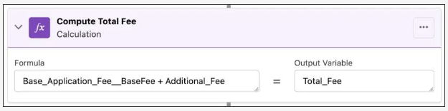
The formula for this final step takes the Base Application Fee from the decision matrix and the Additional Fee from the first calculation step and adds them all together. The final output is simply the Total Fee.

Save the Rule and Simulate
Jessica feels good about the rule but wants to test it out before adding it to any guided flows. The Expression Set Builder gives you a handy simulation tool to do just that.
On the Input Details tab of the simulation tool, add the required input variables.
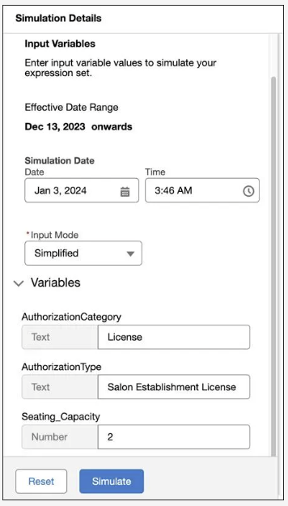
For inputs, specify the area, authorization category, authorization type, and seating capacity of a business. Then, click Simulate to test the expression set. On the main panel, the simulation results quickly appear, so you can review the execution of each step.
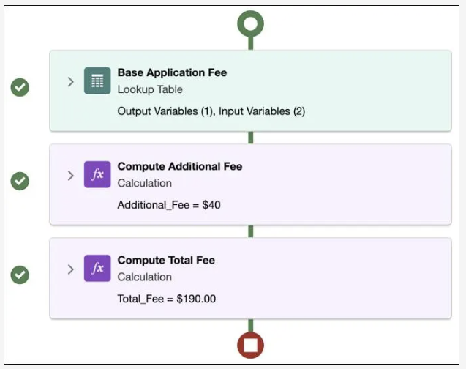
The main panel shows the output for each step. The checkmarks to the left of each element indicate there are no errors. Based on the provided inputs, the Total Fee for this business application is $190.
If she likes, Jessica can expand each step to view more details. This feature comes in super handy when troubleshooting.
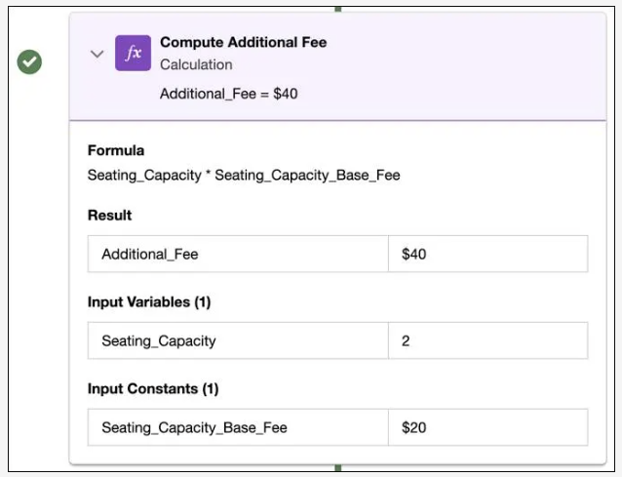
The screen shows the calculation step for computing the additional fee, which is $40 because the seating capacity is 2.
On the left panel, expand View JSON Results for more technical details about the execution of each step. Reviewing the JSON is another way to help solve potential issues.
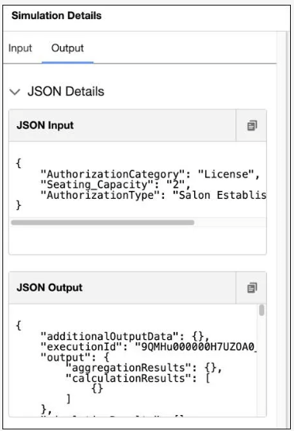
Jessica is seriously impressed with how easy it is to build and test her new expression set. She also finds out about more advanced features, such as aggregation and conditional branching. Jessica rubs her hands together. She plans on using those features for her more complex rules.
After simulating a couple of times with different inputs, she’s confident that the rule is ready to add to Zercovana’s guided flow for the application fee. Phew!

Expression Set Templates
Instead of creating complex expression sets from scratch, use templates to speed things up. Just view a template, save it as an expression set, and start editing it.
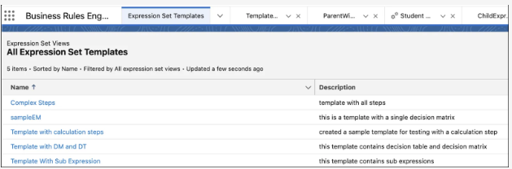

Implement Rules in Business Processes

Business Rules Deployment
After building rules with these tools, the next step is to deploy the rules to users in an actual business process. You can invoke business rules with multiple workflow tools to support different industry contexts.
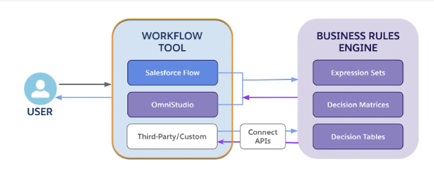
Business Rules Engine components are available for use in Salesforce Flow and Omnistudio. You can use Connect APIs to integrate Business Rules Engine with any workflow created with third-party or custom tools. Your chosen workflow then passes the inputs to Business Rules Engine, returning the outcome to the workflow. In turn, the workflow displays the outputs to the end user.
This table summarizes the different workflow tools available for calling business rules.
Workflow Tool | Integration with Business Rules Engine
Salesforce Flow | Expression sets, decision matrices, and decision tables are all available as actions in Salesforce Flow.  Invoke decision matrices and decision tables independently or as elements of an expression set.
Omnistudio | Omniscripts and Integration Procedures are core Omnistudio components that give you a configurable way to create dynamic business processes.  Add action components to Omniscripts and Integration Procedures to call decision matrices and expression sets.
Custom or third-party tools | Use Connect APIs to invoke expression sets, decision matrices, and decision tables in workflows created with custom or third-party tools.
The workflow tool you use depends on the specific business context.
Because Zercovana’s guided process for the application fee is particularly well suited to Omnistudio, they go with Omniscripts.
In other business scenarios, Salesforce Flow functionality may be just the ticket, while some companies may rely on custom workflows for their guided processes. Either way, Business Rules Engine serves all business users flexibly.
Let’s see the implementation process in action by checking back in with the Zercovanian team, who are ready to bring everything together.

Tying the Knots
Zercovana built a decision matrix and expression set to support their application license fee.
Now that these business rules are in place, it’s time for Zercovana to implement them in a guided process.
Zercovana knows they have several implementation options, but after careful consideration, they decide to go with an Omniscript because it provides a seamless, dynamic user experience for their application process.
Enter Alex Park, Zercovana’s resident Omnistudio wizard, responsible for designing Zercovana’s Omniscript user flows.
Using the Omniscript Designer, Alex builds the main structure for the application fee-guided interaction, ensuring it collects the needed inputs.
You can create a step that collects critical information about the application, including its authorization category and authorization type.
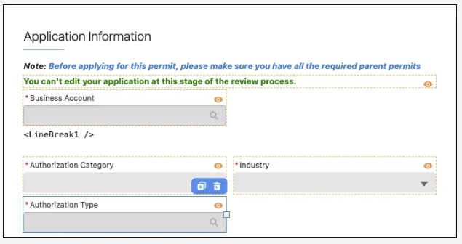
After configuring the Omniscript to collect all the inputs for the expression set, you then add an Expression Set Action element that invokes the appropriate expression set.
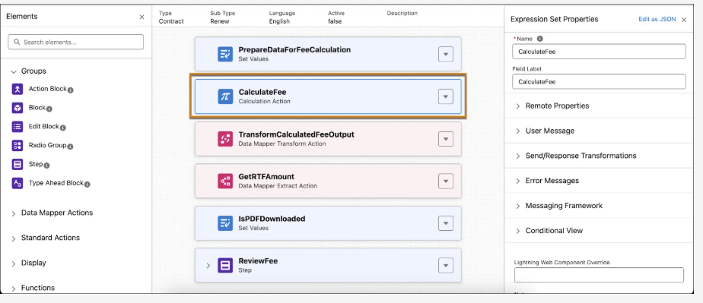
In the Expression Set Name field, give your expression set a name.
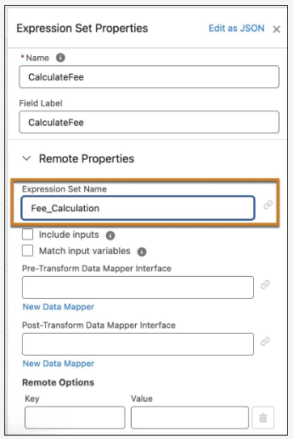
As long as the input fields and values from the Omniscript match the fields configured for the expression set, the expression set runs and returns its output to the Omniscript.
Finally, Alex adds a Review Fee step that displays the outputs from the expression set back to the user in a simple summary table. All the fees reference a specific output from the calculation results of the expression set.
Understand the basic sequence.
- The Omniscript collects the needed inputs.
- The Omniscript invokes the required expression set.
- The expression set displays the outputs to the user.
Now that you know how to invoke an expression set, let’s see how it all comes together for the end user.

Reaping the Benefits
After finalizing the design and testing the functionality of the application fee-guided process, the team at Zercovana embeds the guided process inside their newly launched government business portal.
Donisha Smith, a citizen of Zercovana and a prospective small business owner, is the inaugural user of the new license fee application experience.
First, Donisha logs into Zercovana’s business portal.
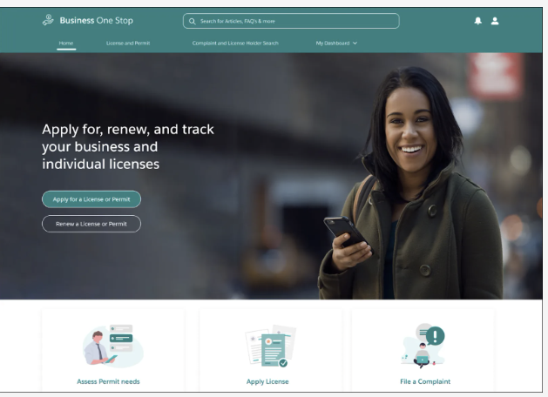
She clicks Apply for a License or Permit, immediately launching the guided flow that Alex configured.
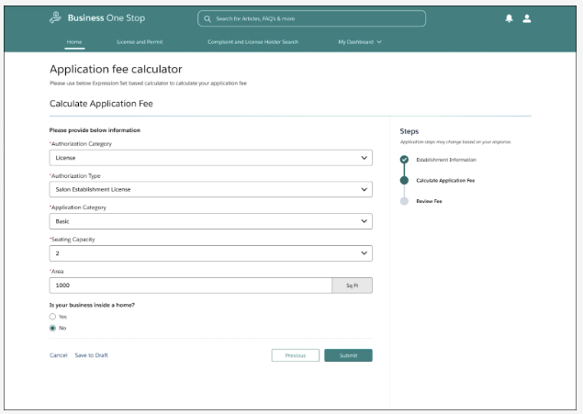
Donisha fills in the required information, which is easy because Alex has set up each field as a dropdown menu that references the available fields from the corresponding Salesforce objects. This way, there’s no possibility of user error, and the expression set is guaranteed to run correctly.
When Donisha clicks Submit, the guided flow immediately sends a call to the expression set, providing it with all the needed inputs from her submission.
Instantly, the expression set sends all its calculation outputs back to the guided flow, which displays the fee details.
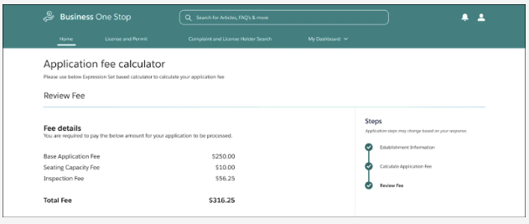
In total, Donisha owes $316.25 for the total fee, and she can easily review the breakdown of fees.
With a simple one-two-three, that’s it! Donisha submits the application fee and is ready to launch her new salon. She couldn’t be more thrilled.
Over the next few weeks, word gets around about Zercovana’s much-improved citizen experience. They see an almost immediate surge in business applications and a tangible lift in overall public morale.
Fuelled by the success of this pilot project, Zercovana plans several new public initiatives. They know Business Rules Engine will play a central role in making all their services more efficient, reliable, and effective.

